Great American Insurance Program (GAI)

Project Owners
Anne-Sophie Sédillot et Cynthia Gauthier
Concept
Launched December 15th, 2024, this program will allow us to fund transactions without having to get proof of insurance from the client, GAI will give MHCC a protection right from the beginning of the contract. For covered transactions, GAI will have the responsibility to follow-up with clients after funding to ensure proper coverage, either through client's own policy or by force placing the GAI protection after 60 days. After this period, if GAI does not receive client’s insurance, client will be automatically billed and collected for the insurance coverage, as provided by the Insurance clause in all our contracts.
After the 60 days delay, only a valid proof of insurance that meets MHCC Insurance policy requirements will trigger a reimbursement process in which they will take the date of coverage into consideration to calculate reimbursement amounts.
GAI will also handle the renewal process during the term of the contract as well as the Claims.

Validation Procedure
The transaction must meet all 4 requirements listed below in order to qualify for this program. If the Transaction does not meet all 4 of these requirements, Insurance coverage is mandatory.:
- Contract is not an assignment
- Contract < 1MM$
- Contract term between 12 and 84 months
- Contract with 100% covered assets, meaning :
  - 100% of the assets are non-plated
  - 0% of the assets generate a Vision automated warning based on the asset category. Some equipment category are excluded from GAI coverage (example : aircraft, Drones, etc.). If one of the category is excluded from GAI, the warning will appear when deal is flipped from “Doc Review” to “Validation” and to “Funding”.

Vision
Warning Generated in Vision when a contract isn’t covered by GAI, meaning we need client COI :
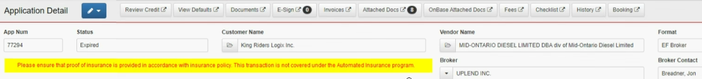
New checkbox will be added in Insurance Tab and will be automatically ticked if the file is covered by GAI, that will identify contracts that need to be sent to GAI. We will always have the possibility to override it and untick it, if needed.
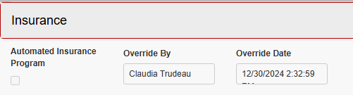

Exception – Excavators
Excavators under category « heavy» and «small machinery» are covered by GAI but there will be a warning that says that the contract isn’t covered as this type of equipment is plated in Quebec. The rule can’t be modified for VIN match tracking purposes.
So when you’ll see this warning for excavators' contracts, here is what to do:

Québec: In the Insurance tab, please check the automated insurance program box:

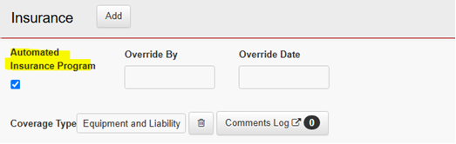

All other provinces: In the equipment tab, please uncheck the plated box in the equipment tab:
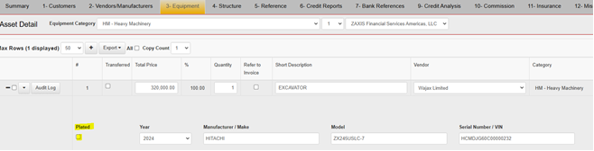

Additional Information
If we receive a COI from the client in a contract where GAI would apply, here is what to do :
- Sales Support or Sales Operation must send the COI directly to GAI mentioning the contract number and using the email address : 5860.VerifyInsurance@gaig.com

- Sales Support should also add a note in the Audit request template to let V2 know that this step was completed

- We do not have to validate the content of this COI, GAI will handle this part for us

- We do not have to integrate insurance datas in Vision
If we receive a COI from the client post-funding in a contract where GAI would apply
- Sales Support or Sales Operation must send the COI directly to GAI mentioning the contract number and using the email address : 5860.VerifyInsurance@gaig.com, CC to insuranceca@mhccna.com

Exclusion list by Equipment Category
In Yellow are the obvious plated equipment that wouldn’t be covered. The rest are specific exclusions from GAI.
